UNIVERSITY OF CENTRAL PUNJAB

RESTAURANT MANAGEMENT SYSTEM

1. RestoPro — Web-Based CRUD Application

SOFTWARE TESTING DOCUMENT

Field | Details
Student Name | Simran Iftikhar
Roll Number | L1F24BSCS0675
Subject | Web Application Development
Technology Stack | PHP | MySQL | HTML | CSS | JavaScript
Database | restaurant_db (XAMPP/MySQL Port: 3307)
Project URL | http://localhost/Restaurant_system
Submission Date | 8-June 2026

Github:

https://github.com/L1F24BSCS0675/SEM4_DB_project

Link:

Open browser and go to: http://localhost/Restaurant_system/auth/login.php

1. Login Page — Screenshot

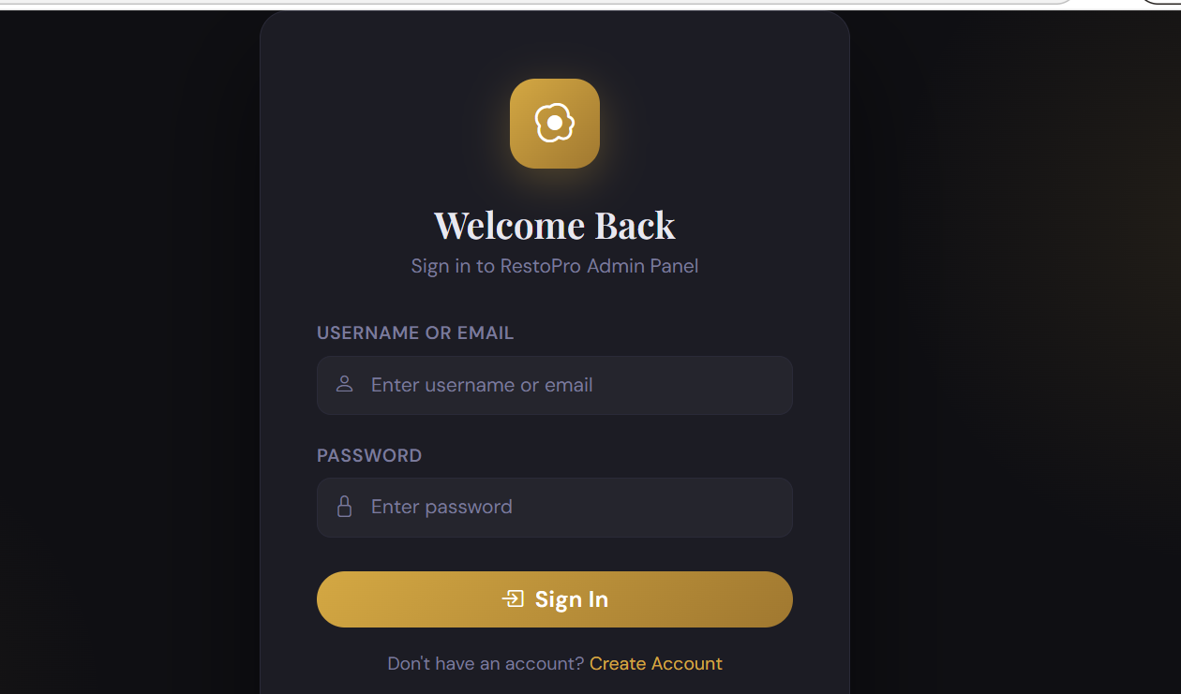

1.3 After Successful Login — Dashboard Screenshot
Enter Username: admin | Password: password → Click Login

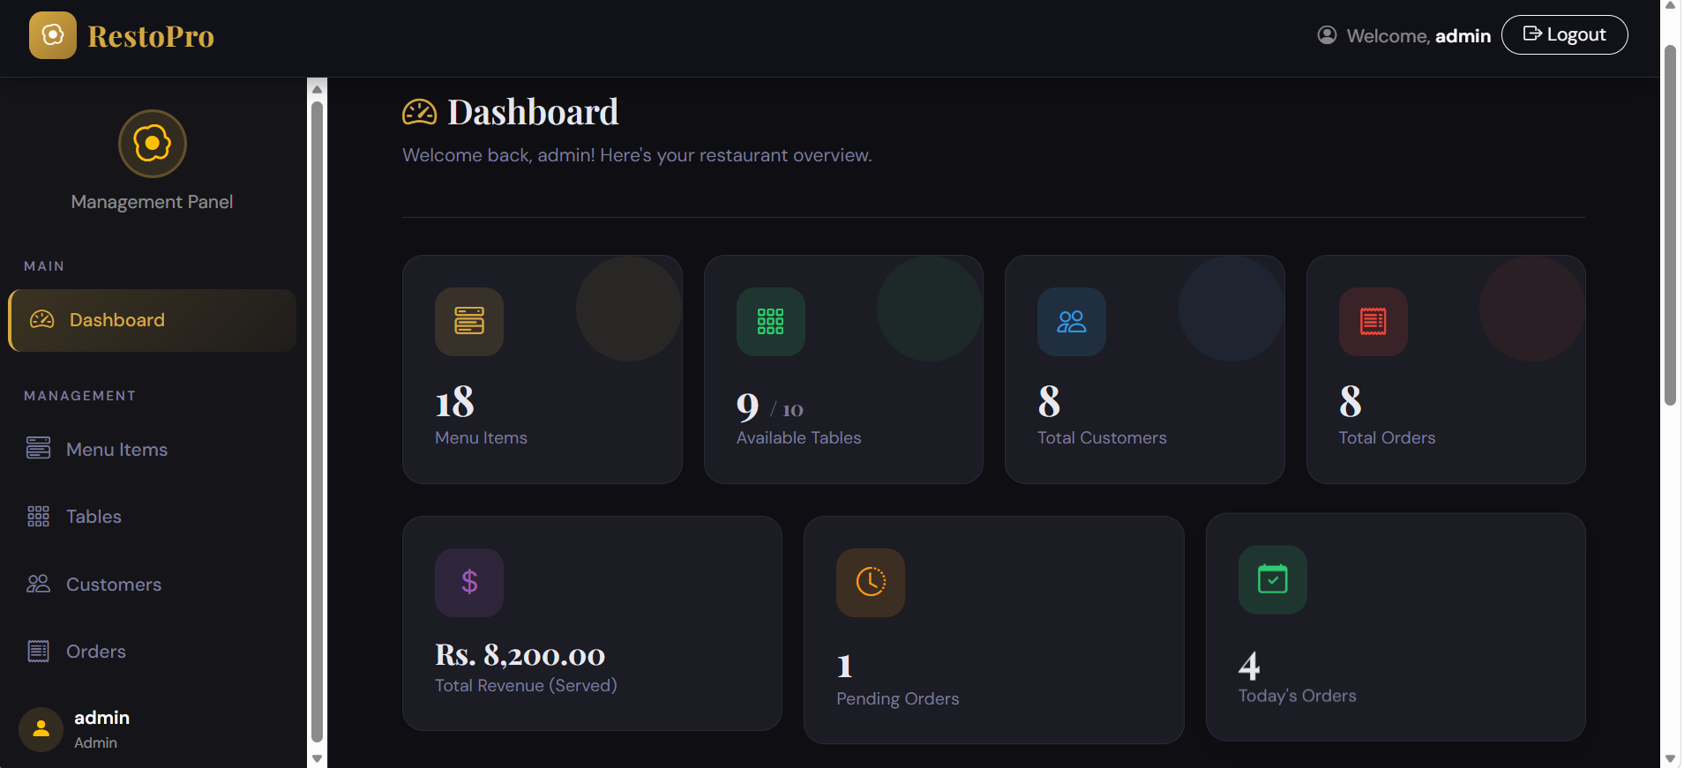

2. Dashboard Testing

2.1 Dashboard Overview Screenshot

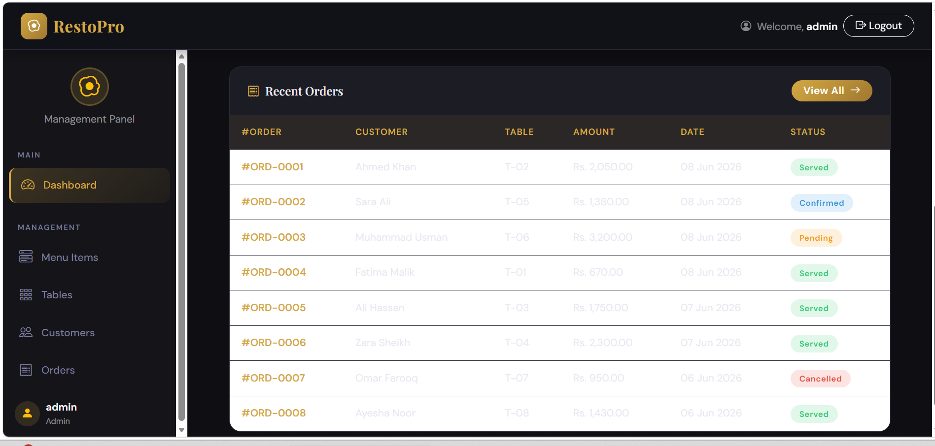

Menu Items — CRUD Operations Testing

Testing all Create, Read, Update, Delete operations for the Menu Items module.

3.1 READ — View All Menu Items

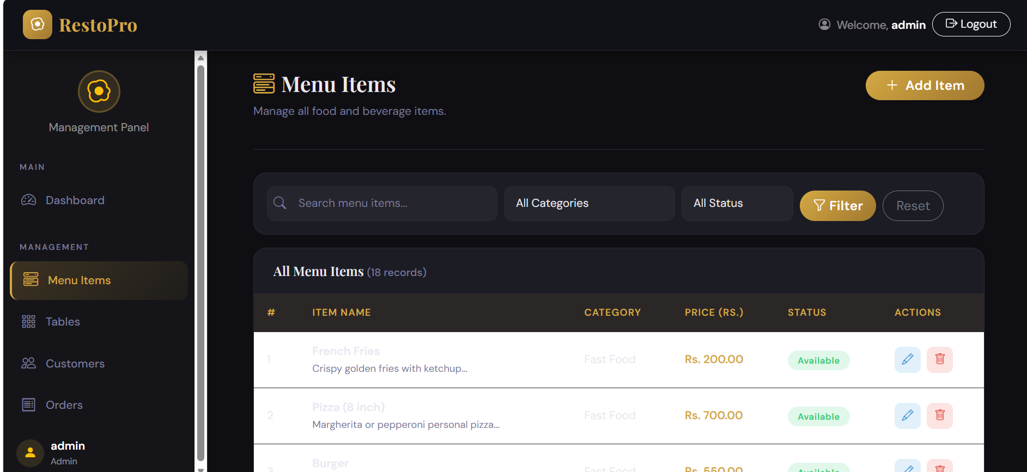

3.2 CREATE — Add New Menu Item

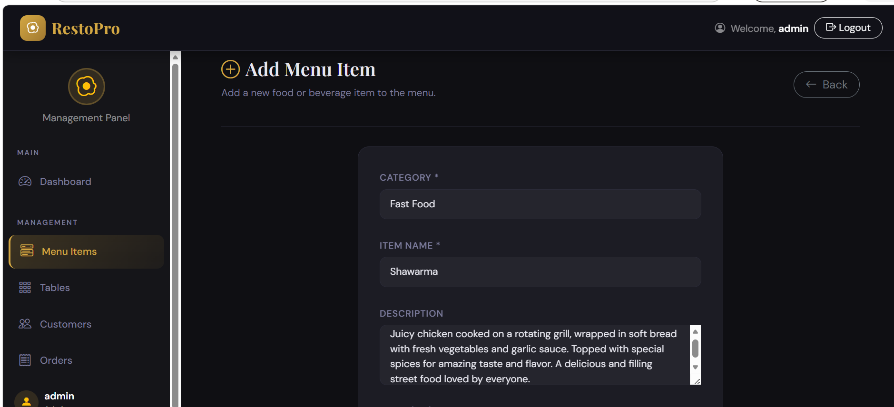

3.3 SAVE ITEM

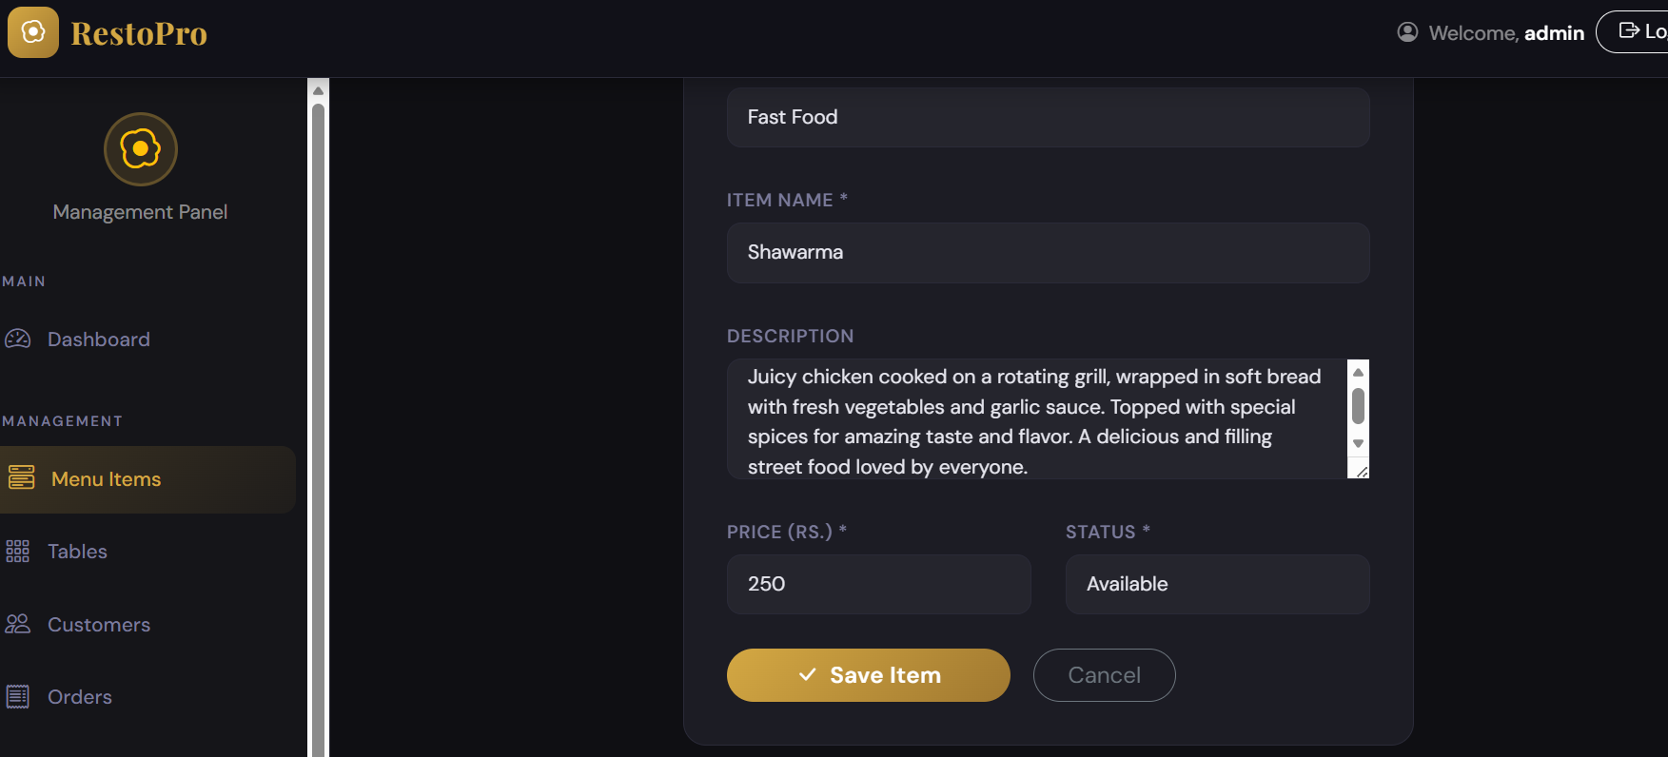

3.4 ADDED IN MENU

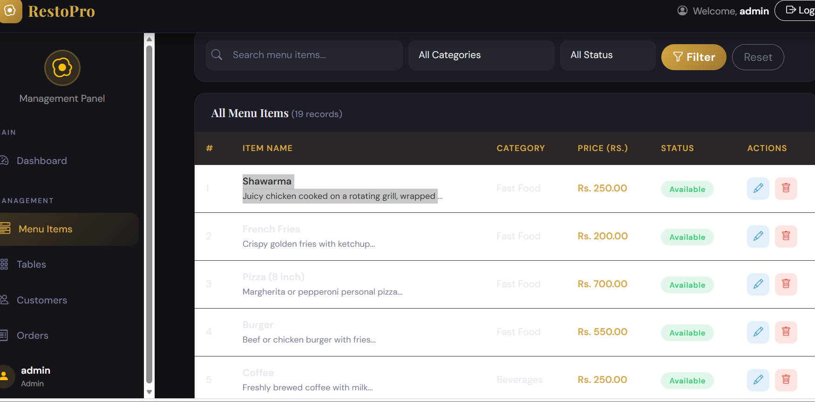

3.5 UPDATE — Edit Menu Item

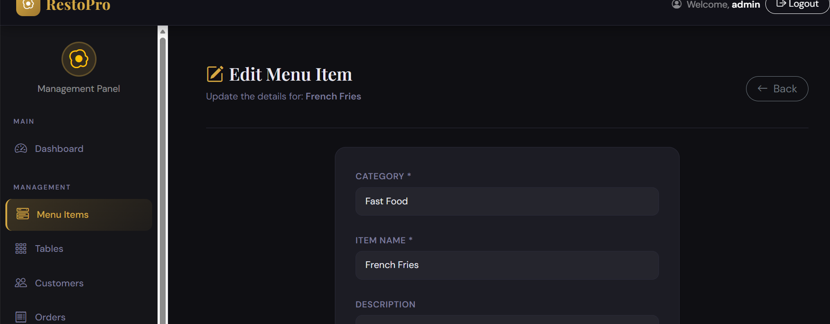

3.6 SAVE EDITED ITEM

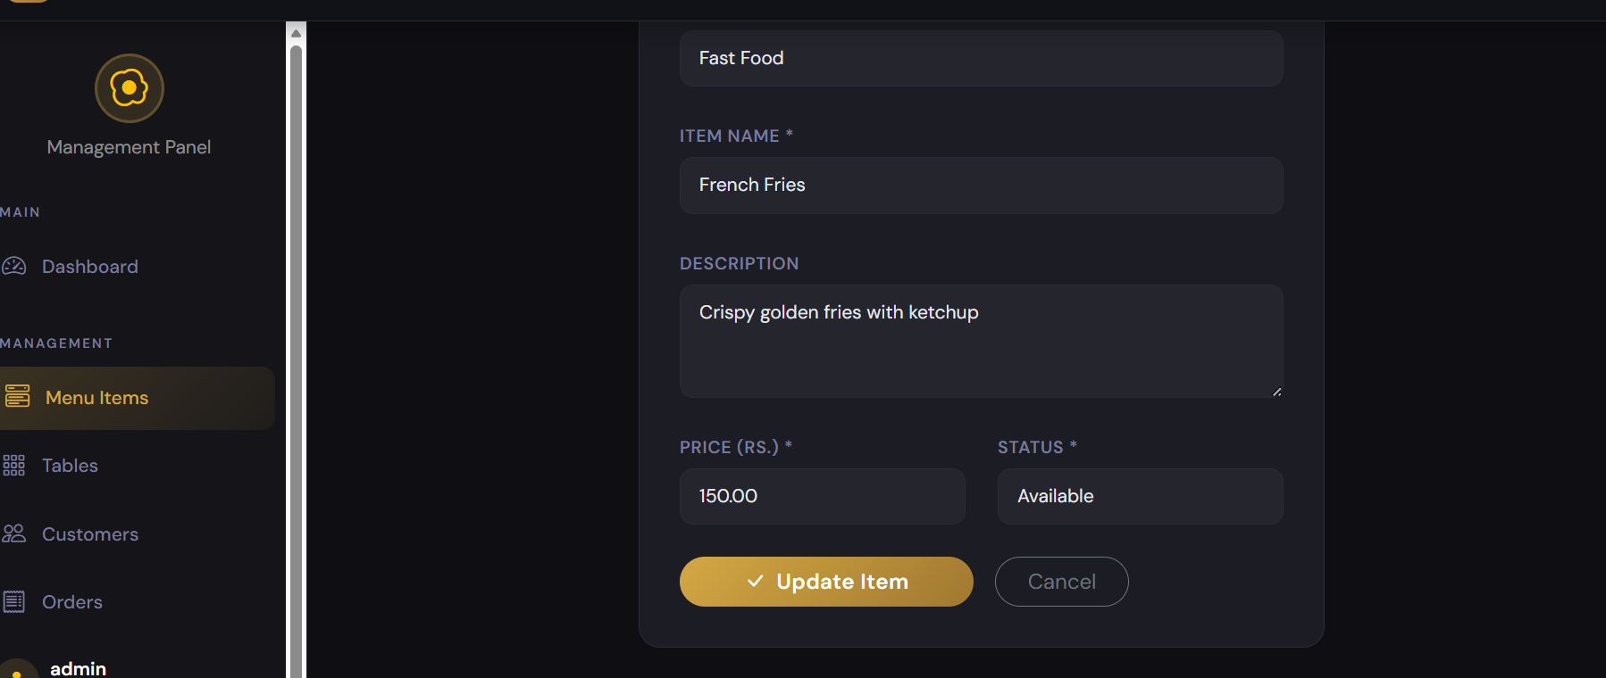

3.7 ADDED

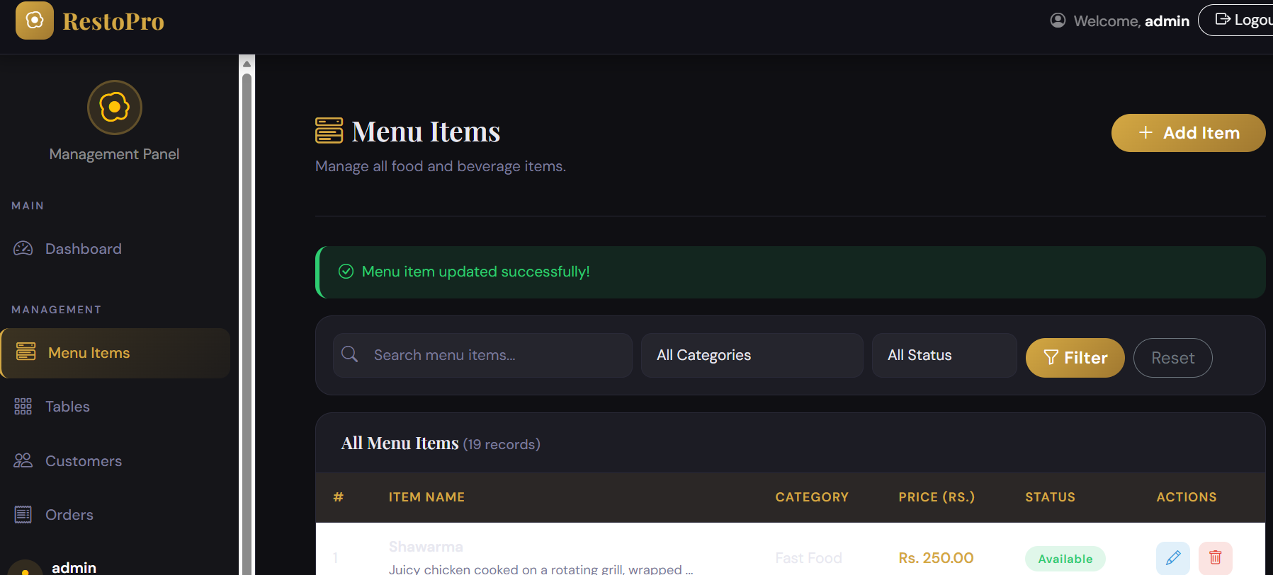

3.8 IN MENU UPDATE FRENCH FRIES PRICE:

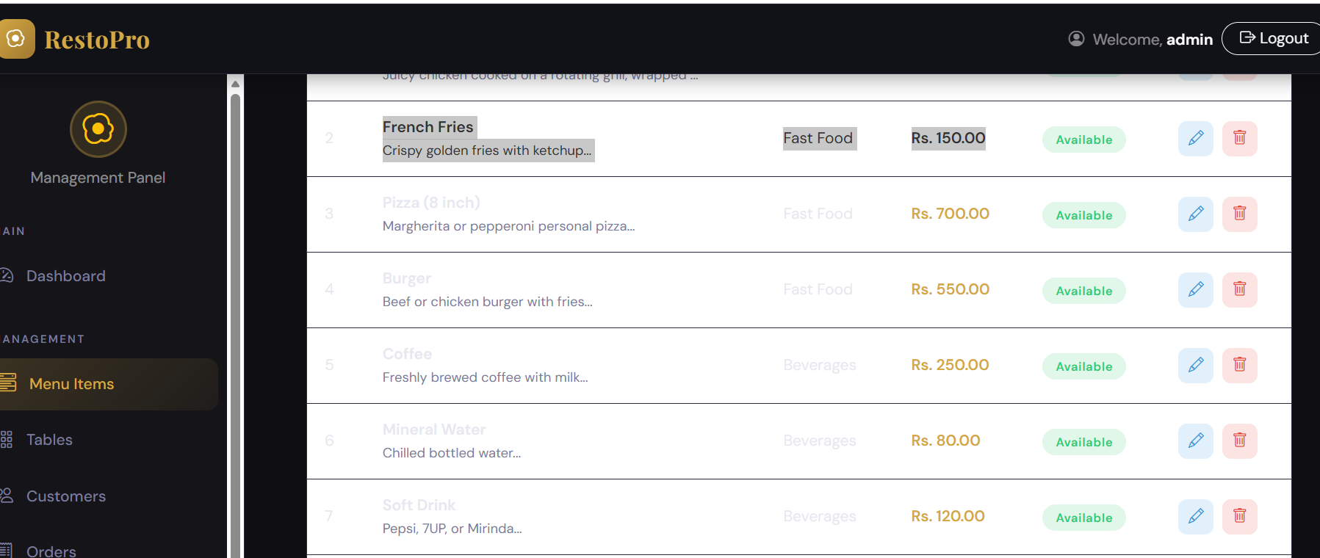

3.9 DELETE — Remove Menu Item

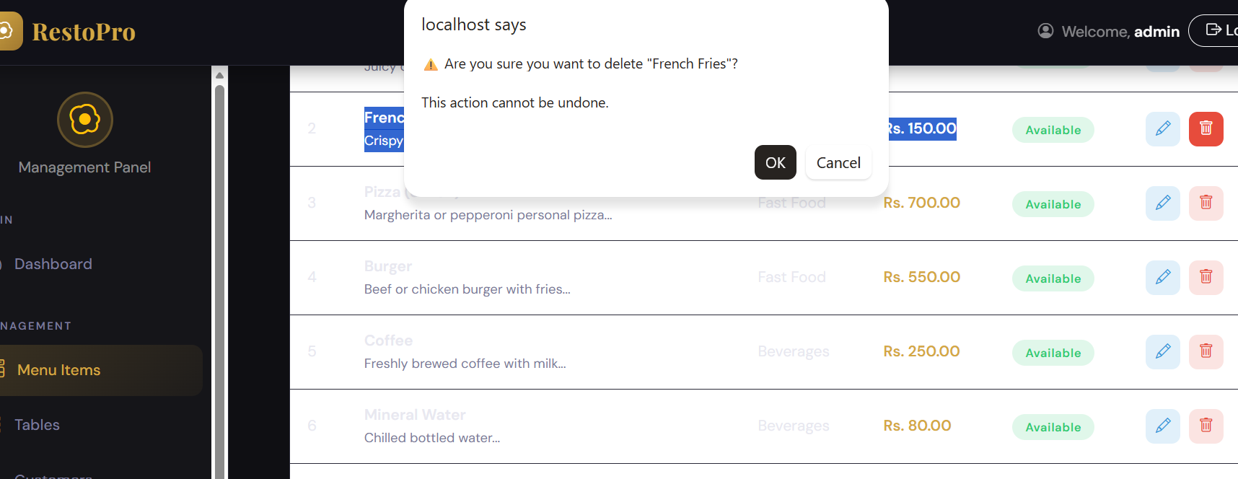

3.10 ITEM DELETED

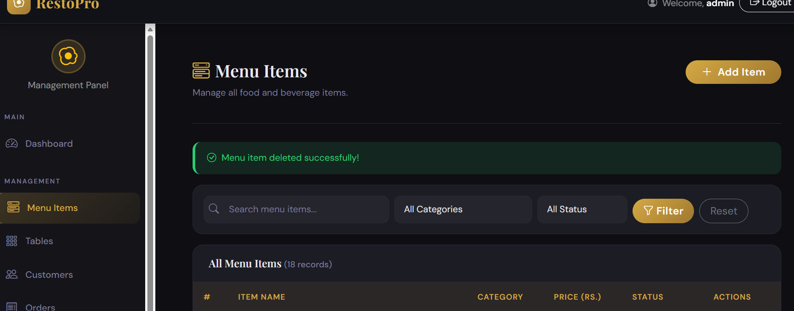

4. Tables — CRUD Operations Testing

4.1 READ — View All Tables

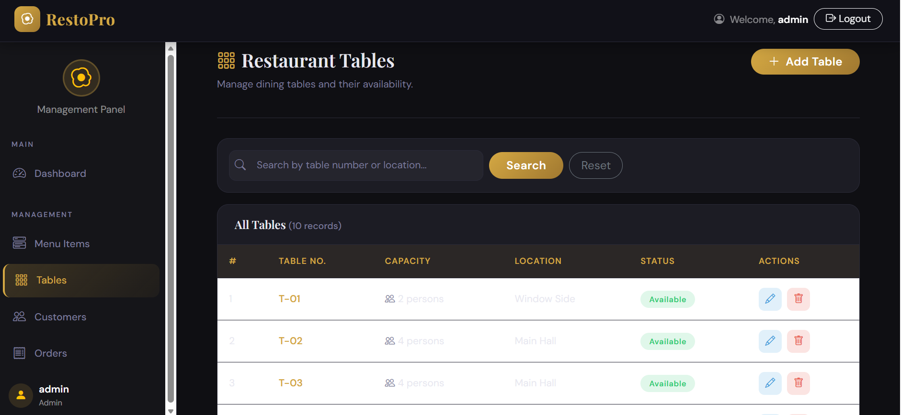

4.2 CREATE — Add New Table

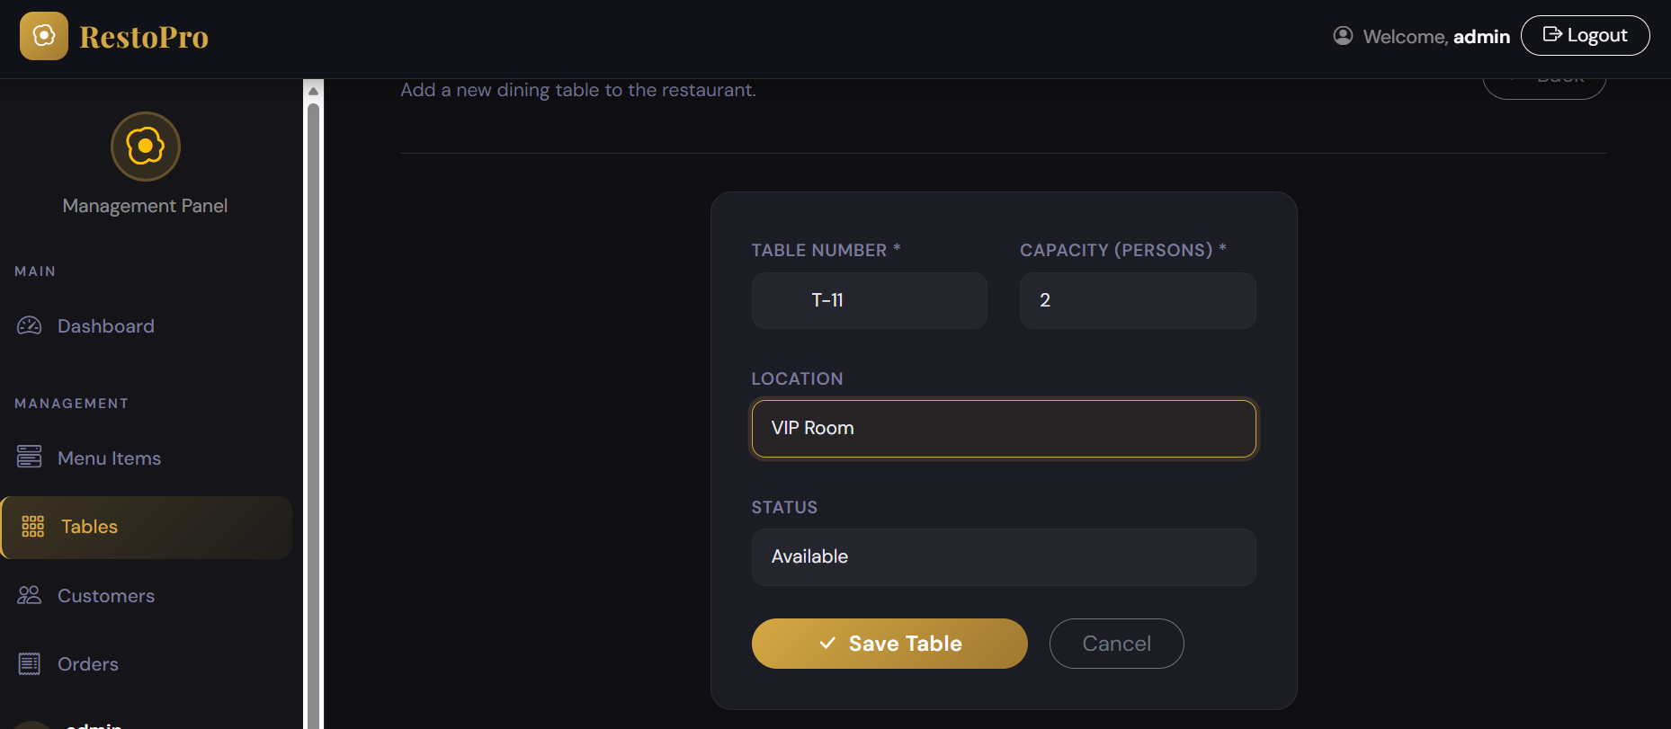

4.3 Table added

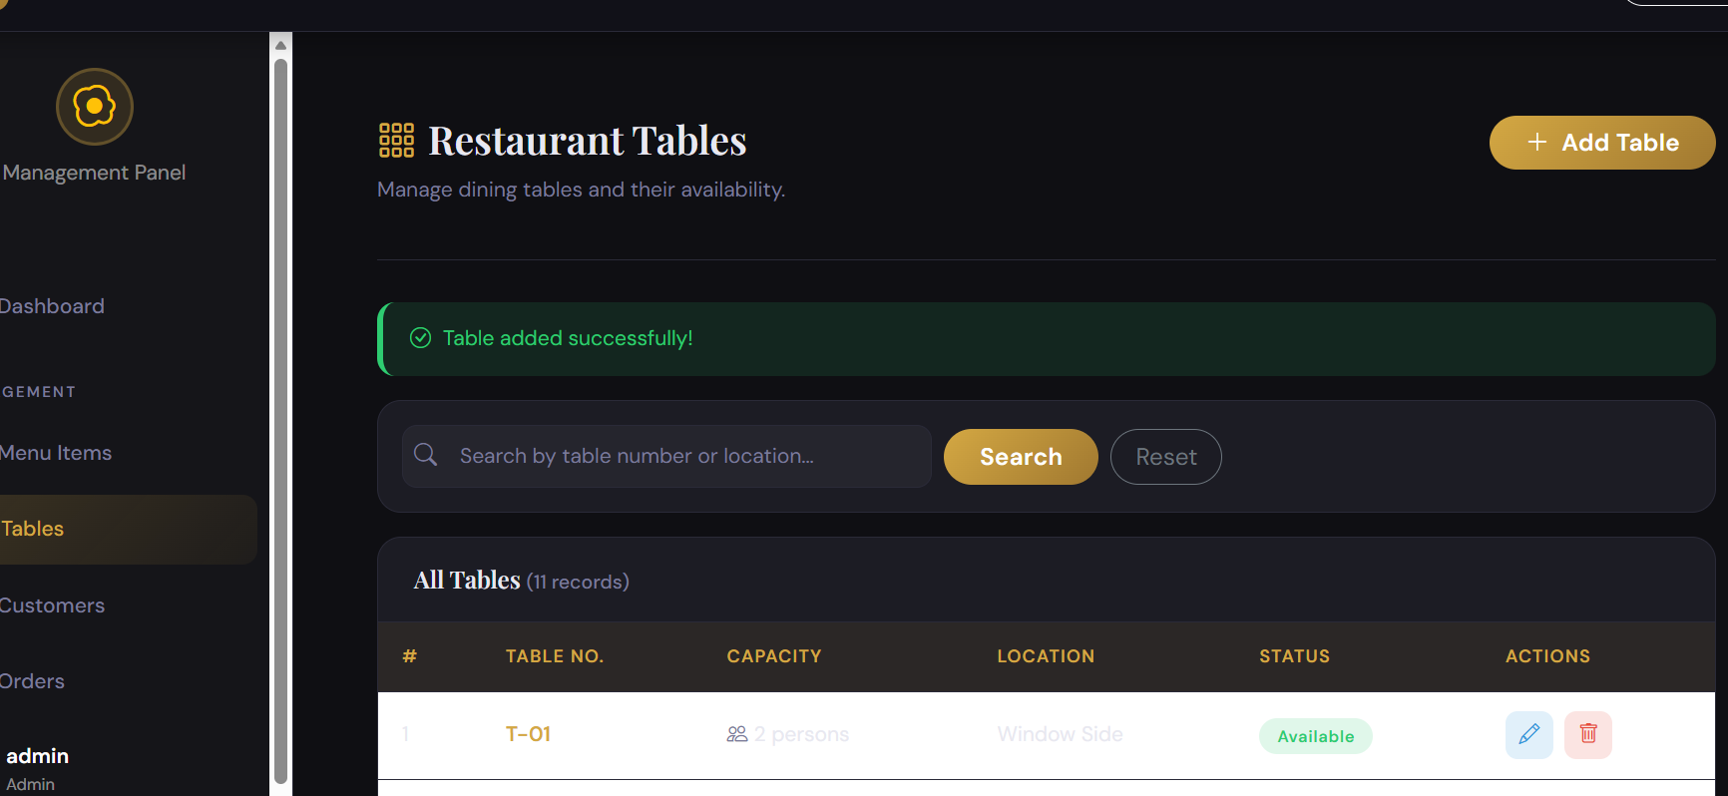

4.4 ADDED IN ALL TABLES

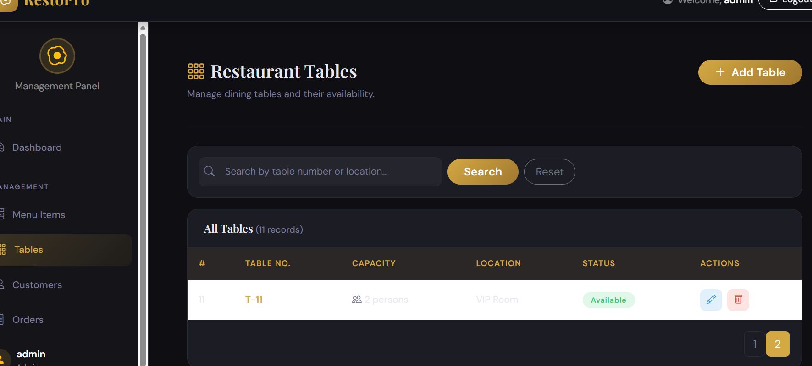

4.5 UPDATE — Edit Table
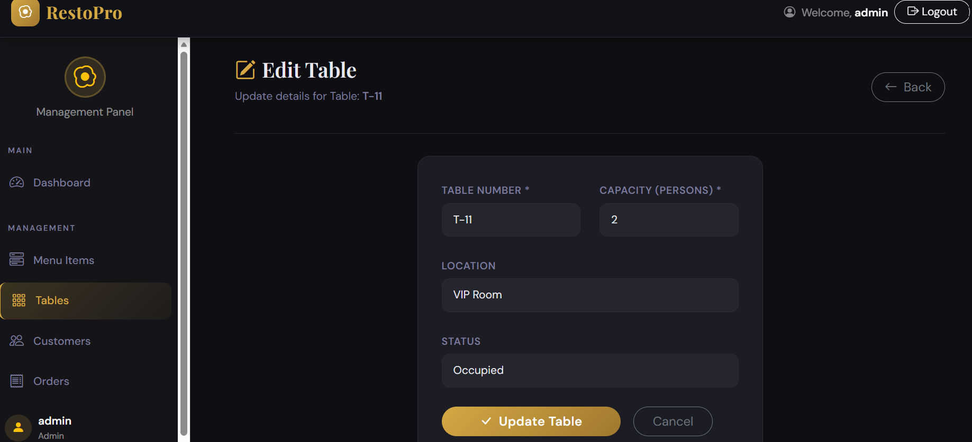

4.6 UPDATED

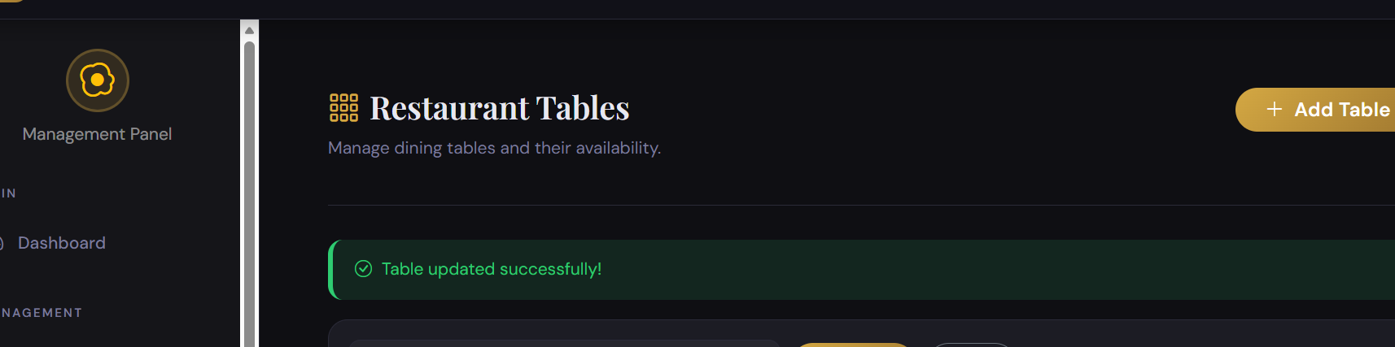

4.7 TABLE STATUS UPDATED FROM AVALIABLE TO OCCUPIED

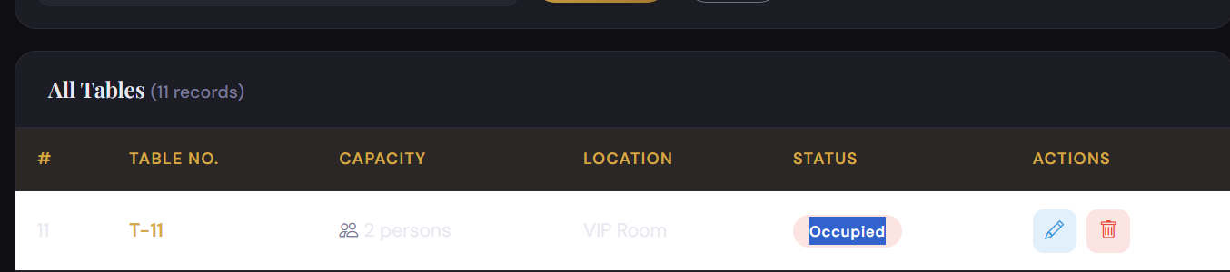

4.8 DELETE — Remove Table

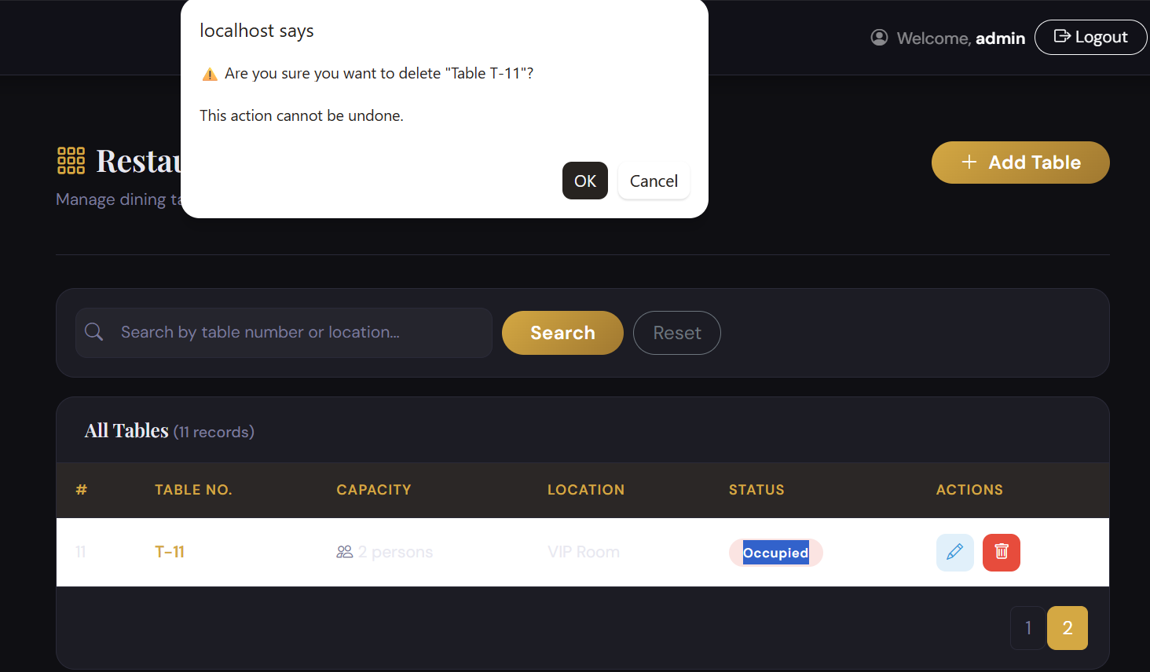

4.9 DELETED

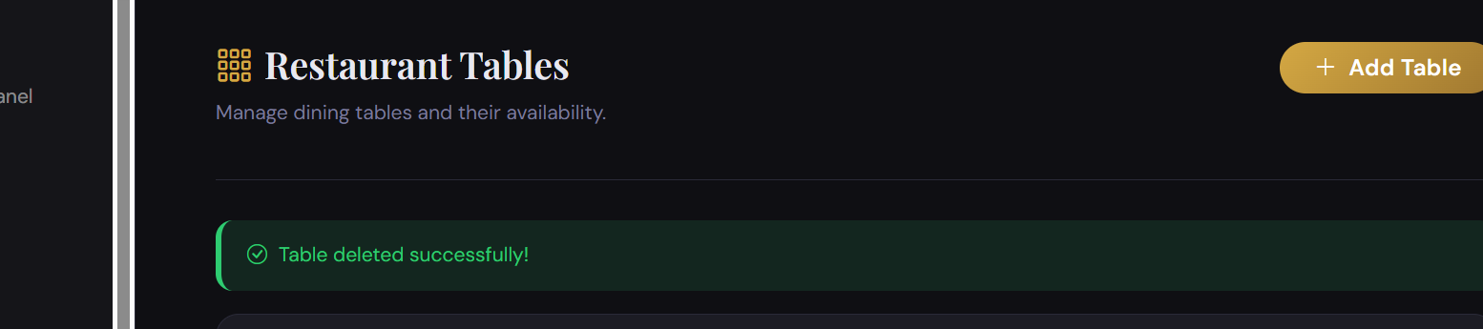

5. Customers — CRUD Operations Testing

5.1 READ — View All Customers

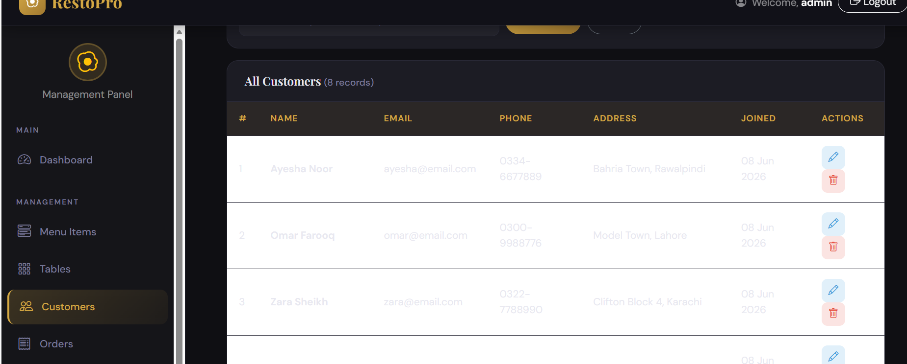

5.2 CREATE — Add New Customer

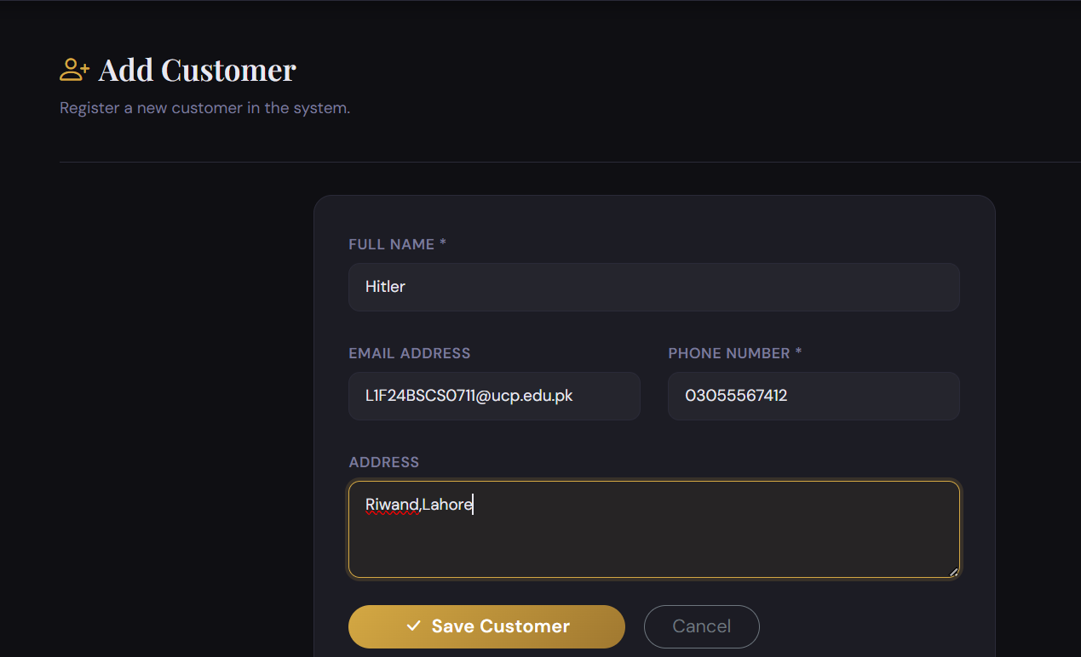

5.3 ADDED

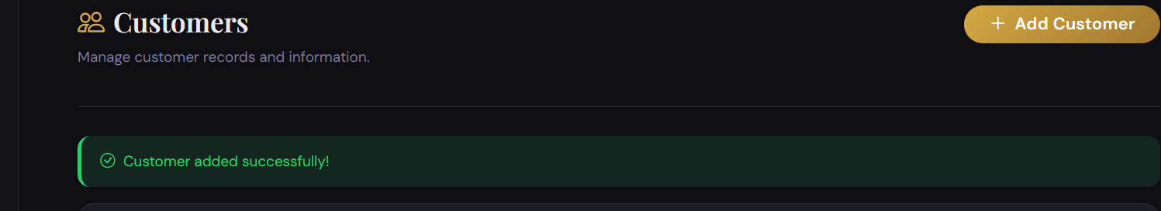

5.4 CUSTOMER ADDED IN THE LIST

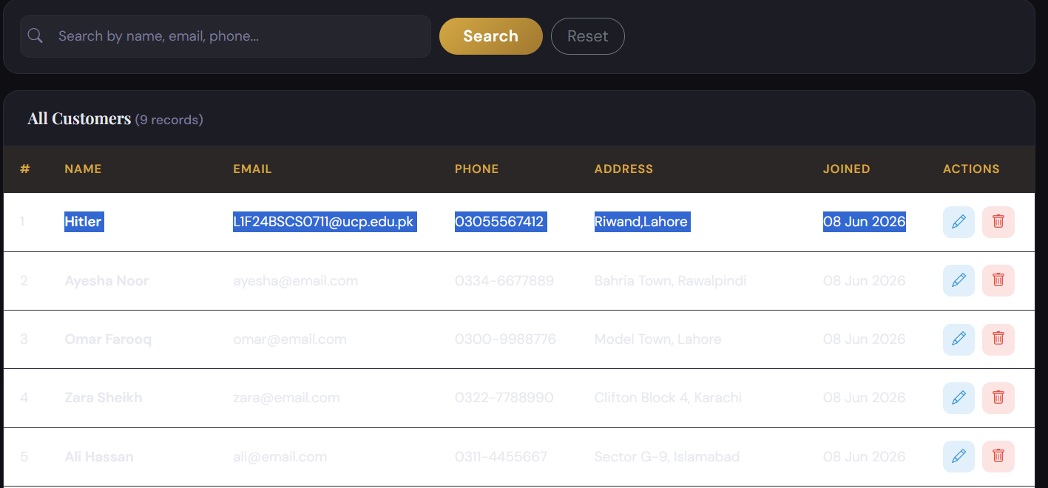

5.5 UPDATE _Edit Customer

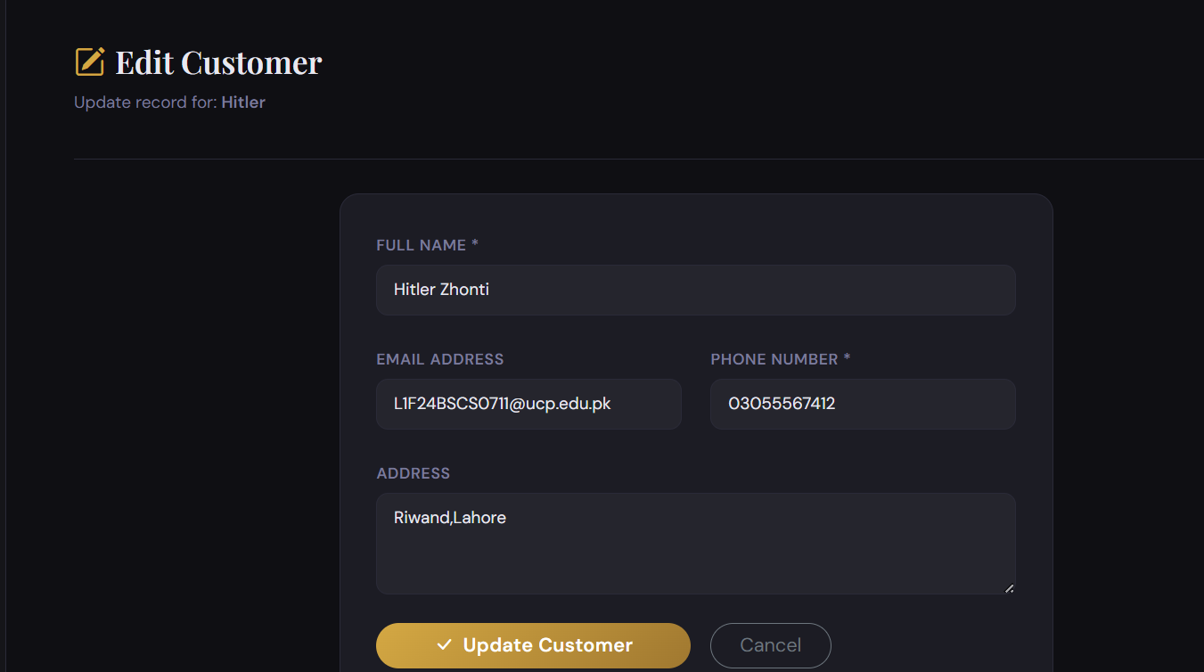

5.6 Updated name

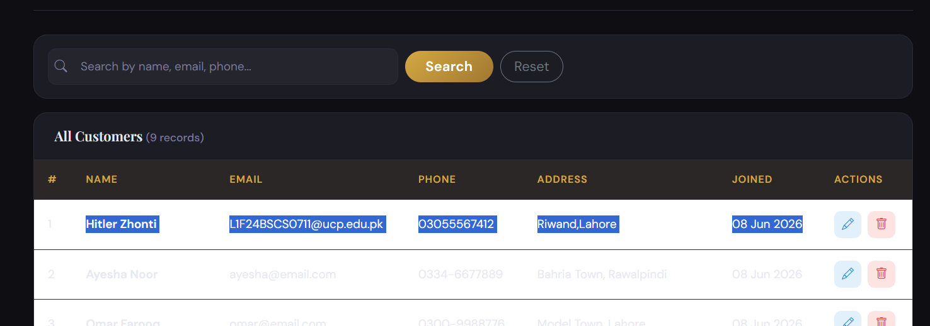

5.7 DELETE — Remove Customer

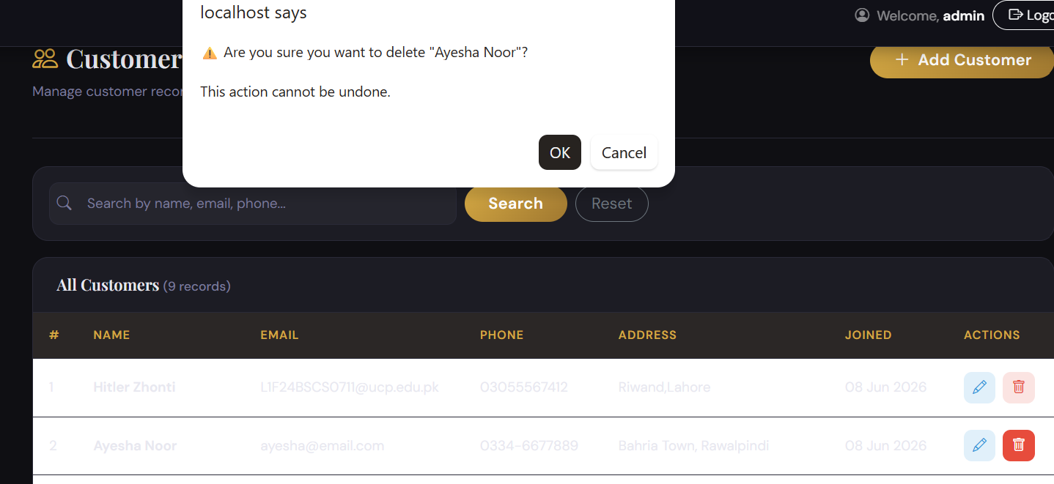

5.8 DELETED

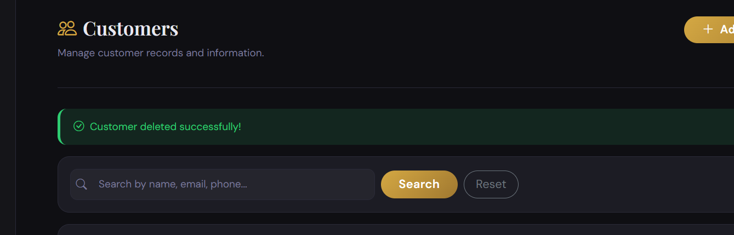

6. Orders — CRUD Operations Testing

6.1 READ — View All Orders

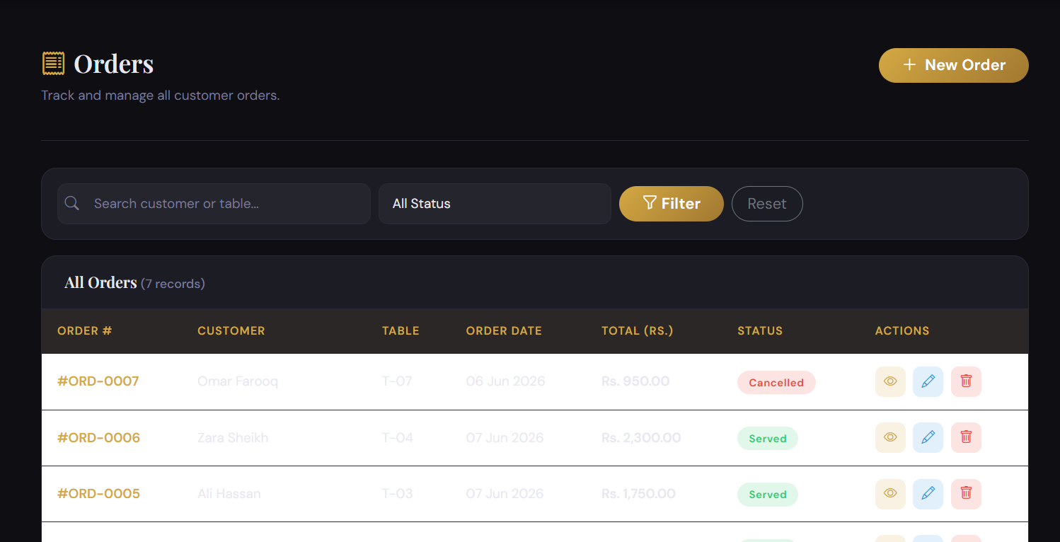

6.2 CREATE — Place New Order

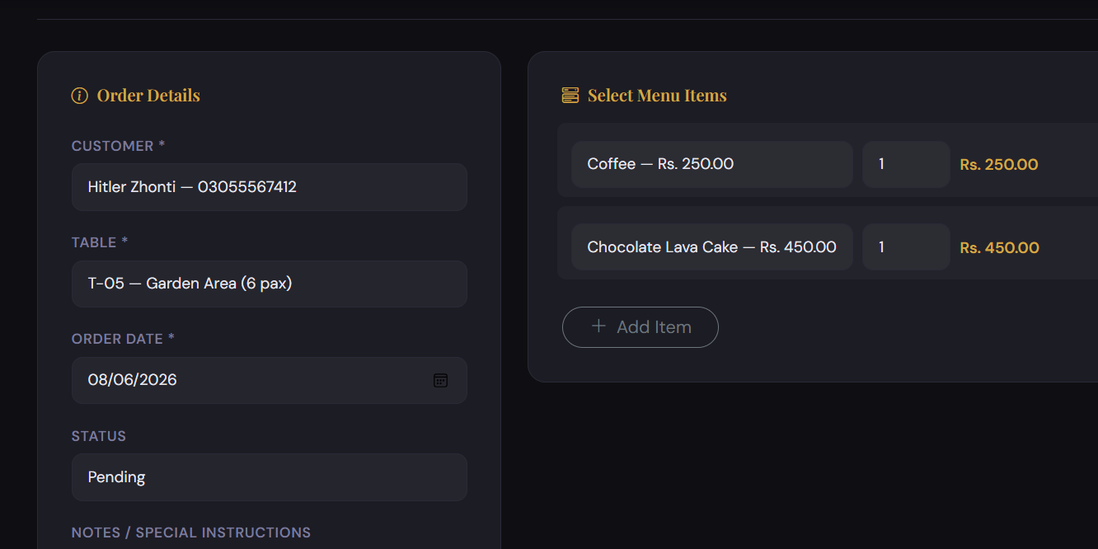

6.3 Total Order Price

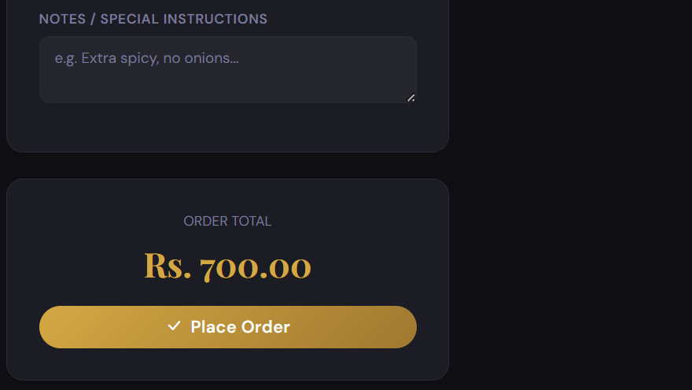

6.4 Added new order

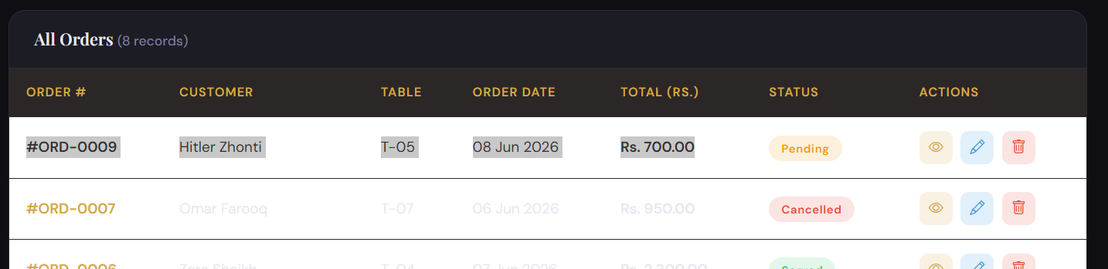

6.5 VIEW RECEIPT — Order Details

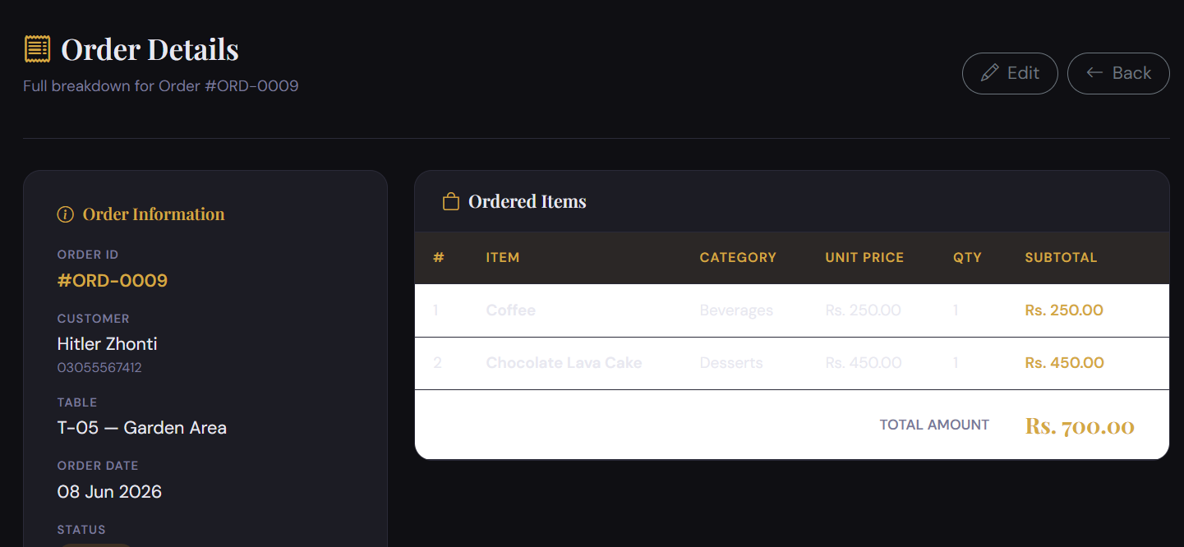

6.6 UPDATE — Edit Order Pending to Served

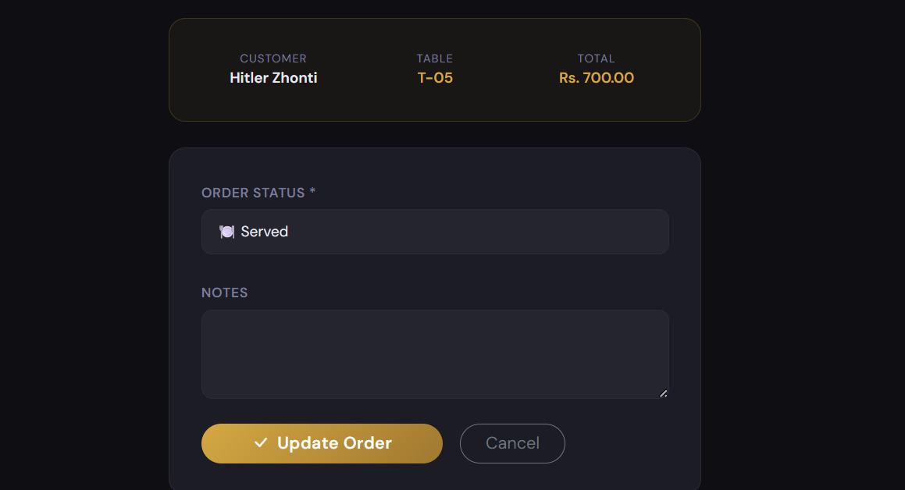

6.7 DELETE — Remove Order

